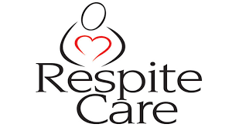
Family Member Satisfaction Survey

Thank you for taking the time to complete the survey below. The questions should take no more than 5 minutes, but will provide us with valuable information to enhance our program! Once completed, please e-mail the survey to Britt.Feldman@navy.mil.

On a Scale of 1-5

1=strongly disagree 2=disagree 3=neutral 4=agree 5=strongly agree NA=Not Applicable

Please rate the following:

- Did you receive an initial phone call within 24 business hours of your request for Urgent Respite Care?

- Did you have good, clear communication with your Fleet and Family Support Center case manager?

- Were you provided Urgent Respite Care services in a timely manner?

- Rate your overall experience with your Urgent Respite care provider?

- Were you given appropriate resources that will provide longer term support for your family?

- Please rate your overall experience with your Fleet and Family Support Center case manager?

Please list any additional feedback you would like to share in the space below!

Thank you again for completing the survey!

If you would like to speak to someone further about your Urgent Respite care experience please contact Britt Feldman at britt.feldman@navy.mil, 360-315-5170.

